

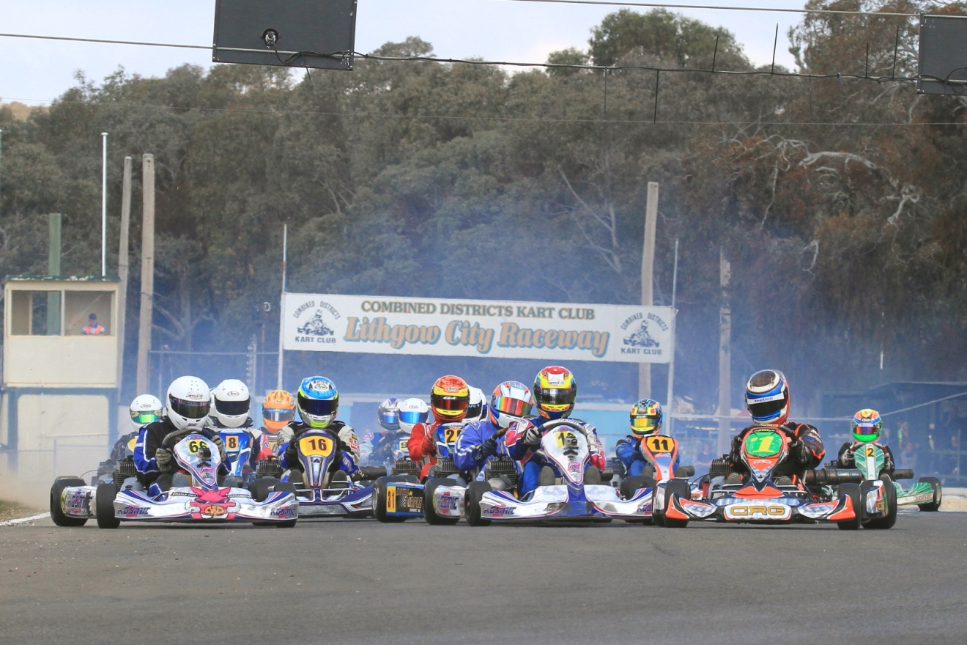

Round 6 - 2016 CDKC Club Championship

|  |  |  |  |  |
| --- | --- | --- | --- | --- |
| Sunday 25th September 2016   |  |  | | --- | --- | | Classes | Racing Details | | Cadet 9  Cadet 12  KA4 Junior Light  KA4 Junior Heavy  KA 4 Snr Light/Heavy/Masters  KA3Snr Light/Heavy/Masters  TAG 125 Light  TAG 125 Heavy  TAG Restricted Light  TAG Restricted Heavy  KA3 Junior  Junior Performance | 4 minute practice  Computer gridding  3 heats of (8 laps each)  Pre Final (10 laps)  Final (12 laps)  Final only counts  Pre Entry $95 each  Pre entries close 21.9.16  All entries after this date will be $130 each | |

Practice 9.00am to 5.00pm Saturday

Come and enjoy a great racing atmosphere

[www.cdkc.com.au](http://www.cdkc.com.au)