

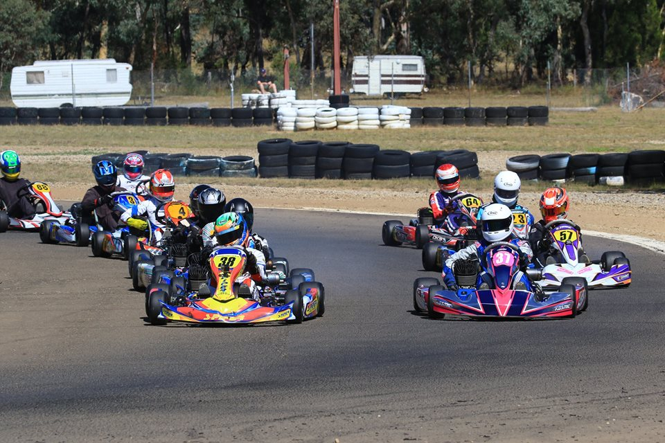

Round 2 - 2017 CDKC Club Championship

& Col’s Castle Cup for Cadet 12

1st Race on the New Surface

|  |  |  |  |  |
| --- | --- | --- | --- | --- |
| Sunday 30th April 2017   |  |  | | --- | --- | | Classes | Racing Details | | Under the new group  Structure, any KA kart can enter  We anticipate groups will be  Cadet  Junior KA4  Junior Higher Performance  Senior KA3  TAG Restricted  TAG  This will be entry dependant more info and trophy policy on the website | Qualifying  3 heats of (8 laps each)  Final 15 laps  Winner of Cadet 12 will be awarded the Col’s Castle Cup  Pre Entry $100 each  Pre entries close 25.04.17  All entries after this date will be $140 each | |

Practice 9.00am to 5.00pm Saturday

Complete track re surfaced

Come and enjoy a great racing atmosphere